SMS Management

Overview

Current processing
Currently all PAR client logs in using PAR Server and PAR Adapter and PAR Adapter takes care of managing this relationship and login and logout through SMS. When the PAR client user, e.g. “ABC” logs in on workstation e.g. “W060” using PAR server e.g. “PS15” PAR adapter creates the hierarchy for PAR server “PS15” and user as “ABC:W060” in the SMS. And OHS store this location information as “PS15: ABC:W060”

New requirement
As PAR client will login through CAS similar to Trader GUI or OMT user, CAS will register this PAR user XXX:Wxxx (e.g. ABC:W060) under SMS and create the session for it. The SMS will send accept login event for this user (ABC:W060) and OHS will consume this event and put in separate PAR user cache, when this user logs out SMS will send accept logout event and OHS will consume this event remove this user from PAR user cache.

OHS will first check the new PAR user cache to determine if the user is logged in, if it does not find it there then it will look into old PAR Adapter based cache using the workstation information to determine if user logged in (old style). If user or workstation not found in either (new or old) caches then it will be considered as not logged in.
- If the user is logged in new style then OHS will publish the request to “Order Routing” channel.
- If the user is logged in old style then OHS will send the request using synchronous CORBA call.

Assumption
- Simple and Complex requests will use the same mechanism.
- PAR user e.g. “ABC” will be defined in User Management/Security service.
For detail please refer to Requirement document.

Implementation
The existing classes will be used for this functionality are:
- ManualOrderDestinationMonitor – This is the interface for monitoring SMS related changes and marking the component up or down accordingly.
- ManualOrderDestinationMonitorImpl – This is the wrapper implementation for monitoring SMS related changes and marking the component up or down accordingly.
- ManualOrderDestinationDelgate – This contains actual implementation for monitoring SMS related changes and marking the component up or down accordingly. New cache for PAR broker/user “loggedInPARUserCache” needs to be defined will get populated or removed when user logs in or logs out.

There will be new class implemented as part for Send/Publish message to PAR functionality:
- WFStepPublishOrSend – This will work like a switch between old style send using synchronous CORBA call or new style publish to “OrderRouting” Event Channel.

Implementation Details

- Initialization – New cache (Map) for PAR broker/user “loggedInPARUserCache” will be defined to store all logged in PAR broker/user. The key for Map will be user e.g. “ABC:W060” and value will CAS as source name e.g. “cas01v2dev23cas” for any logged in user using the SMS services.
- Log In – While OHS is running any new PAR broker/user logs in (“ABC:W060”) will be tracked and put in the new cache “loggedInPARUserCache” as described above. The OhsSMSUserConsumer will consume the log in event from SMS using acceptLogin and will call addLoggedInUsers on ManualOrderDestinationMonitor to add this user to cache.
- Log Out - While OHS is running any PAR broker/user logs out (“ABC:W060”) will be tracked and removed from the new cache “loggedInPARUserCache”. The OhsSMSUserConsumer will consume the log out event from SMS using acceptLogout and will call removeLoggedInUsers on ManualOrderDestinationMonitor to remove this user from cache.
- Send or Publish Check – Before Order or related requested gets routed the workflow step WFStepPublishOrSend will be checked to determine if the workstation (W060) logged in using new style (then publish) or old style (then send) if nothing found then return failure. Log in check will pass workstation e.g. W060 to getUserLoggedIn on ManualOrderDestinationMonitor and if workstation is logged in then (for searching this workstation on loggedInPARUserCache map’s key it will concatenate ‘:’ in front of workstation e.g. ‘:W060’) it will return complete string e.g. cas01v2dev23cas: ABC:W060 otherwise null.

Below is the envisioned graph with this new approach of login:

OHS view of SMS
ABC:W060 [Logged In] ====> cas01v2dev23cas [ ACTIVE/ACCESSIBLE ] ====> v20Frontenddev23fe [ ACTIVE/ACCESSIBLE ]

System Component Map (SMS)
SOURCE components:
type=SOURCE, group=, id=cas01v2dev23cas, state=ACTIVE, dynamicAdded=false, referencedComponents=[v20Frontenddev23fe]

CONNECTION components:
type=CONNECTION, group=, id=v20Frontenddev23fe, state=ACTIVE, dynamicAdded=false, referencedComponents=[]

CRITICAL components:

Order History
Location: cas01v2dev23cas:ABC:W060

Scripts
- None

Database
- None

SetContext
- None

XML/DTD
- None

Homes/Services
- ManualOrderDestinationMonitor
- ManualOrderDestinationMonitorImpl
- ManualOrderDestinationDelgate

ImplPlan
- Flow Diagram
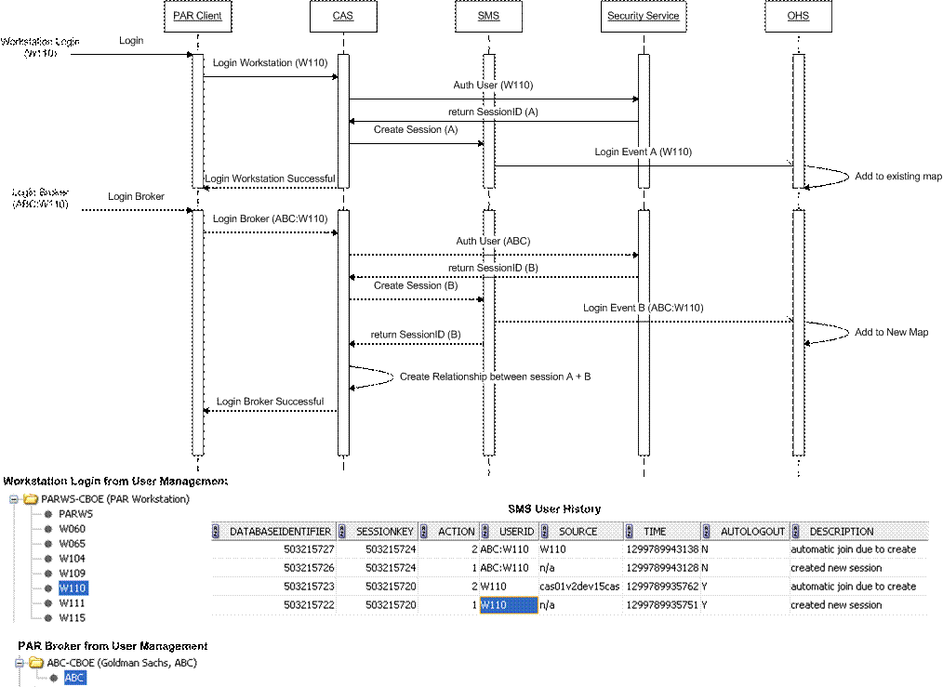

PerformanceTestingProcedure
- .

TestingProcedure

OperatorProcedure
- .

Fallback/Failover

